Given n points on a 2D plane where points[i] = [xi, yi], Return*the****widest vertical area****between two points such that no points are inside the area.*

A **vertical area** is an area of fixed-width extending infinitely along the y-axis (i.e., infinite height). The **widest vertical area** is the one with the maximum width.

Note that points **on the edge** of a vertical area **are not** considered included in the area.

**Example 1:**

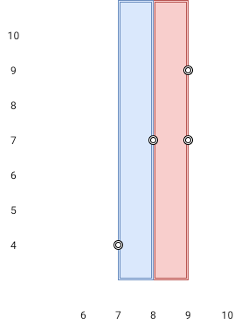​

**Input:** points = [[8,7],[9,9],[7,4],[9,7]]

**Output:** 1

**Explanation:** Both the red and the blue area are optimal.

**Example 2:**

**Input:** points = [[3,1],[9,0],[1,0],[1,4],[5,3],[8,8]]

**Output:** 3

**Constraints:**

* n == points.length
* 2 <= n <= 105
* points[i].length == 2
* 0 <= xi, yi <= 109